TG-51 Worksheet D: Electron Beams using Plane-Parallel Chambers

- Site data
Institution:
Physicist:
Date:
Accel Mfr:
Model & serial number:
Nominal electron energy/beam identifier: MeV

- Instrumentation
a. Chamber model:
Serial number:
Waterproof: yes no

If no, is waterproofing ≤ 1 mm PMMA or thin latex?: yes no
b. Electrometer model:
Serial number:
i.P_{elec}, electrom. corr factor (Sec. VII. B): takes a 1.0 if using cross-calibration.
P_{elec}: C/C or C/rdg

3. Measurement Conditions (point of measurement at d_{ref})
a. Distance SSD: cm
b. Field Size on surface: cm²
c. Number of monitor units: MU

- Beam Quality (Sec. VIII. C)
Measure I₅₀ by measuring depth-ionization curve and, for cylindrical chambers only, shifting curve upstream by 0.5 r_{cav}
I₅₀
a.i. If 2 ≤ I₅₀ ≤ 10 cm: cm
R₅₀ = 1.029I₅₀ - 0.06: cm
ii. If I₅₀ > 10 cm: cm
R₅₀ = 1.059I₅₀ - 0.37: cm
b. Reference depth d_{ref}=0.6R₅₀-0.1 cm

- Determination of 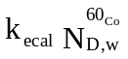 and 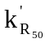 (Sec. X.C)
a. Worksheet C - A:8 or B:3): Gy/C
b. i. from figures [Fig 6 or 8]
or ii. from analytic expression for well-guarded plane-parallel chamber
= 1.2239 –0.145 (R₅₀)^{0.214} [Eq.(20) 2 ≤ R₅₀ ≤ 20 cm

TG-51 Worksheet D: Electron Beams using Plane-Parallel Chambers ( cont).

- Temperature /Pressure Correction a(Sec. VII. C)
a. Temperature: °C
b. Pressure: 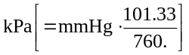
c.P_{TP}: 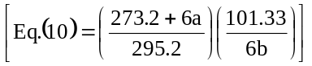
- Polarity Correction (Sec. VII. A)
M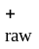: C or rdg
M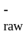: C or rdg
a. M_{raw} (for polarity of calibration): C or rdg
b. P_{pol}: 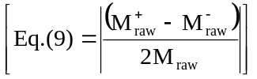
- P_{ion} measurements (Sec. VII. D. 2)
Operating voltage= V_{H}: V
Lower voltage V_{L}: V
M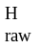: C or rdg
M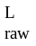: C or rdg
P_{ion} (V_{H}): 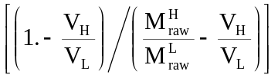
If P_{ion} > 1.05, another ion chamber should be used.

9. Corrected ion. c. rdg M (Sec. VIII)

Fully corrected M (Eq (8)): C

- Dose water at reference depth, d_{ref}

a. Dose to water at d_{ref} = Gy
Gy/MU
b. Dose/MU at d_{ref} = = [10a/3c]

- Dose to water / MU at dmax (if relevant locally)
a. %dd(d_{ref}) as used clinically:
b. Dose / MU at dmax= Gy/MU[10b/(11a/100)]

